A PROJECT REPORT
On
FITNESS CLUB MANAGEMENT SYSTEM
Submitted by Samruddha Mestry
(Seat no: -__43__)
in partial fulfilment for the award of the degree
of
BACHELOR OF SCIENCE
In
COMPUTER SCIENCE
Under the guidance of
Prof. Mr. VIJAY VASTAVA
Department Of Computer Science



K.M. Agrawal College of Arts, Commerce and Science

(2026-2027)
K.M. Agrawal College of Arts, Commerce and Science

Department Of Computer Science

CERTIFICATE
This is to certify that Mr. Samruddha Mestry of T.Y.B. SC.CS (Sem VI) class seat no- 43 has satisfactorily completed the project Fitness and Club Management System is to be submitted in the partial fulfilment for the award of Bachelor of Science in Computer Science during the academic year 2026-2027.

Project Guide Head/InCharge,
Department Computer Science

College Seal Signature of External Examiner

DECLARATION

I, Mr. Samruddha Mestry hereby declare that the project entitled ”Fitness Club Management System ” submitted in the partial fulfilment for the award of Bachelor of Science in Computer Science during the academic year 2026-2027 is my original work and the project has not found the basis for the award of any degree, associate-ship, fellowship or any other similar titles.

Signature of Student:

Place:

Date:

ACKNOWLEDGEMENT
I have a great pleasure in representing this project report entitled "Fitness Club Management System ." I would like to extend my gratitude to our beloved Principal for their guidance.

I take this opportunity to thank the Coordinator of the Department and all the professors of the Department of Computer Science of K.M. Agrawal College of Arts, Commerce & Science, Kalyan for giving me an opportunity to complete this project and for their most needed guidance throughout the duration of the programme.

I am extremely grateful to my project guide, Prof. Mr. VIJAY VASTAVA, for his valuable guidance and necessary support during each phase of the project. He was the source of continuous encouragement as each milestone was crossed.

Finally, I also owe my thanks to my fellow friends who have been a constant source of help to solve the problems that cropped up during the project development process.

ABSTRACT
The Fitness Club Management System is a comprehensive full-stack web application designed to modernize and streamline the administrative and client-facing operations of a fitness center. Addressing the limitations of manual record-keeping, this project leverages a robust backend built on Node.js, Express.js, and MySQL, coupled with a dynamic frontend using HTML, CSS, and JavaScript. The system features a dual-role authentication mechanism secured by JSON Web Tokens (JWT), allowing members to register, view subscription details, and receive real-time updates via a notification inbox. Administrators benefit from a powerful dashboard offering live analytics, client management tools, and feedback monitoring. This project delivers a scalable, efficient, and user-centric solution that enhances member engagement and simplifies the complex operations of a modern fitness club.

Plagiarism Scan Report
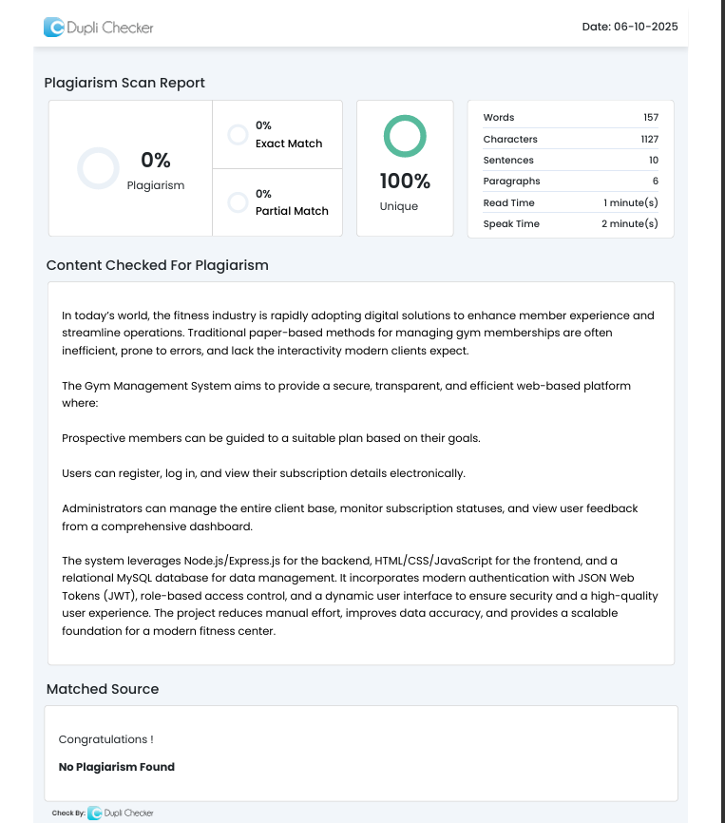

Certificate Of Approval



Index
Sr No. | Topics | Page no.
1 | Introduction | 10
2 | Modules | 11
3 | Objectives | 12
4 | Scope | 13
5 | Event Table | 14 - 16
6 | Gantt chart | 17
7 | Activity Diagram | 18
8 | Flowchart Diagram | 19
9 | Use Case Diagram | 20 - 21
10 | Entity-Relationship Diagram | 22
11 | Data Flow Diagram | 23 - 24
12 | Web Design | 25 - 28
13 | Methodology | 29
14 | Development Environment | 30
15 | Hardware Requirements | 31
16 | Tools And Technologies | 32
17 | Database Design | 33 - 36
18 | System Requirements | 37
19 | Validations | 38
20 | System Code | 39 - 78
21 | System Screenshot | 79 - 81
22 | White Box and Black Box Testing | 82
23 | Future Enhancements | 83
24 | Bibliography | 84

1. Introduction

In today’s world, the fitness industry is rapidly adopting digital solutions to enhance member experience and streamline operations. Traditional paper-based methods for managing gym memberships are often inefficient, prone to errors, and lack the interactivity modern clients expect.
The Fitness Club Management System aims to provide a secure, transparent, and efficient web-based platform where:
Prospective members can be guided to a suitable plan based on their goals.
Users can register, log in, and view their subscription details electronically.
Administrators can manage the entire client base, monitor subscription statuses, and view user feedback from a comprehensive dashboard.
The Fitness Club Management System aims to provide a secure, transparent, and efficient web-based platform where:
- Prospective members can be guided to a suitable plan based on their fitness goals.
- Users can register, log in, and view their subscription details electronically.
- Clients receive instant notifications regarding plan upgrades, expirations, and diet chart updates.
- Administrators can manage the entire client base, monitor subscription statuses, and view user feedback from a comprehensive dashboard.
2. Modules

The Fitness Club Management System is divided into the following functional modules:
User Authentication Module: Handles registration and secure login for two distinct roles: 'client' and 'admin'. Manages user sessions using JWTs.
Subscription Management Module: Allows users to select a membership plan upon registration (including free trials) and creates a corresponding subscription record with a defined start and end date.
Client & Visitor Interaction Module:
Homepage with an interactive "Goal Selector" modal.
Dynamic display of plan details and services.
A functional BMI Calculator.
Client Dashboard Module: Provides a secure, personal area for logged-in members to view their profile, subscription status, and a list of included services.
- Notification Inbox: A real-time messaging interface where clients receive alerts regarding subscription upgrades, plan expirations, and diet updates.
Admin Dashboard Module: A comprehensive interface for administrators to manage the system, featuring:
Live analytic stat cards (Total Members, Active Subscriptions, etc.).
A complete list of all clients with their subscription details.
The ability to delete clients.
A viewer for all user-submitted reviews.Review & Feedback Module: A publicly accessible contact form that stores user feedback in the database for admin review.

3. Objectives

To create a secure and user-friendly platform for managing gym memberships.
To implement a dual-role system (client and admin) with distinct privileges and dashboards.
To simplify client management for administrators through a powerful and intuitive dashboard.
To reduce the cost and effort compared to manual record-keeping.
To provide an engaging user experience for visitors with interactive tools like a goal selector and BMI calculator.
To maintain transparency by allowing clients to view their own subscription details.

4. Scope

In-Scope
User registration with plan selection (Basic, Pro, Premium, Free Trial).
Secure login for both clients and admins.
Role-based redirection to either a client or admin dashboard.
A client dashboard displaying profile info, subscription status, and included services.
An admin dashboard with live analytics, a full client list, review viewer, and the ability to delete clients.
A functional contact form for submitting reviews.
An interactive goal-selector modal and BMI calculator on the homepage.

Out-of-Scope

Payment gateway integration for membership fees.
Advanced admin actions like editing user details or manually changing subscriptions.
Assignment of specific workout or diet plan files.
A mobile application (the project is currently web-based only).

5. Event Table

Event | Trigger | Action | Output
New User Registration | User submits form with a plan selected. | Validate input, hash password, create Users and Subscriptions records. | Account created or error message.
User Login | User enters valid credentials. | Authenticate, generate JWT, return token and role. | Login success, redirect to appropriate dashboard.
View Client Dashboard | Client logs in. | Verify client token, fetch profile and subscription data from DB. | Client dashboard with personal data is displayed.
View Notifications | Client loads the dashboard. | System fetches messages from Notifications table linked to User ID. | User sees alerts about plan expiry or updates.
Admin Views Dashboard | Admin logs in. | Verify admin token, fetch stats, clients, and reviews from DB. | Admin dashboard with live data is displayed.
Send Notification | Admin inserts message via DB/Panel. | System creates a new record in Notifications table. | Message is stored and queued for the user.
Delete Client | Admin clicks "Delete" and confirms. | Verify admin token, delete user's Subscriptions and Users records. | Client is removed from the list.
Submit Review | Visitor submits contact form. | Store the message in the Reviews table. | Confirmation message.

6.Gantt Chart

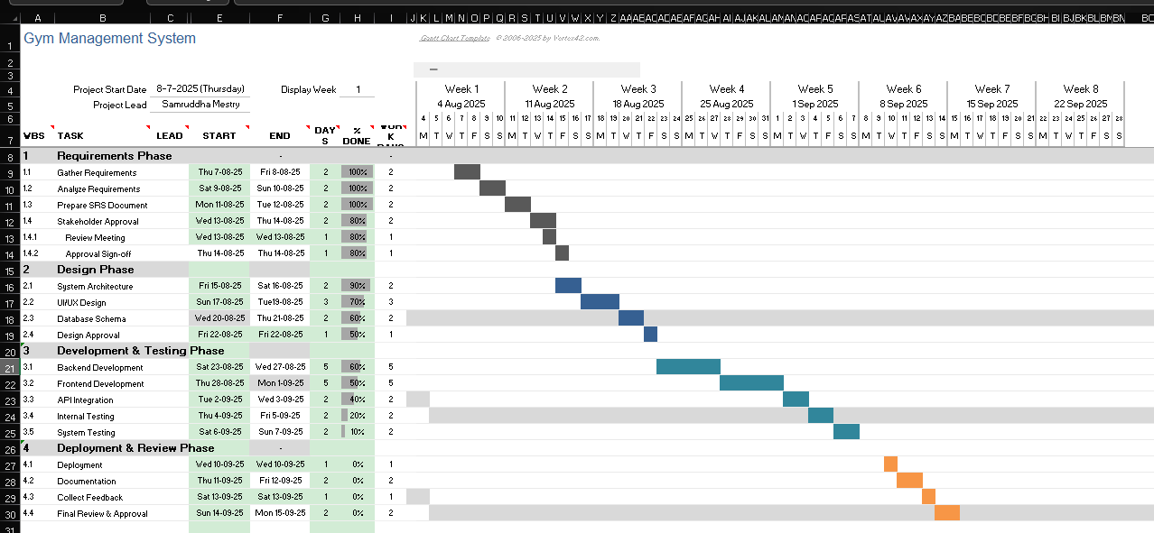

7.Activity Diagram

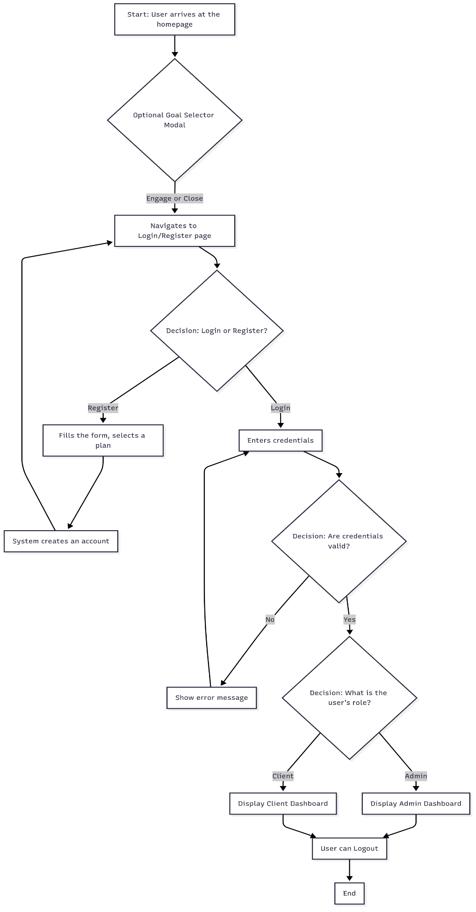
8. Flowchart Diagram

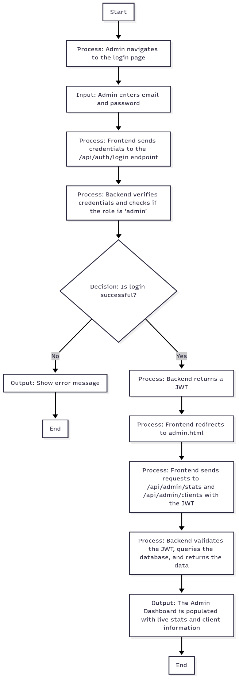
9. Use Case Diagram
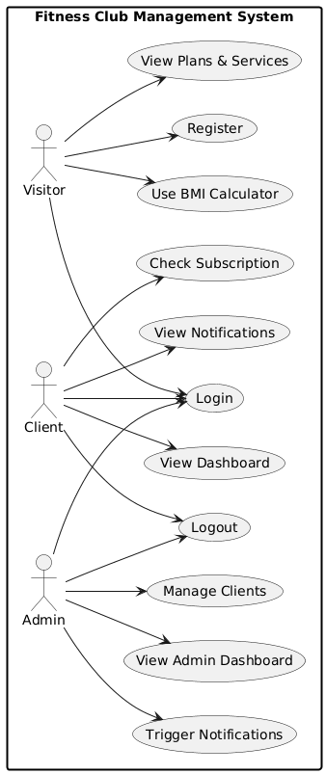

Actors: Client, Admin, Visitor (unauthenticated user).

Use Cases:

Client: Register, Login, View Client Dashboard, Logout.

Admin: Login, View Admin Dashboard, View Client List, View Reviews, Delete Client, Logout.

Visitor: Submit Review, Use BMI Calculator, Interact with Goal Selector.

10. Entity-Relationship Diagram (ERD)
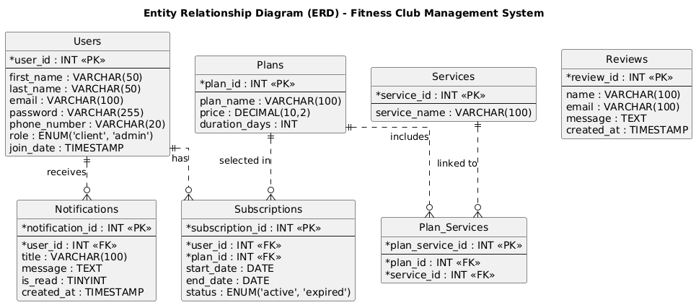
Entities:
Users (user_id, name, email, password, role)
Plans (plan_id, name, price, duration)
Services (service_id, name)
Subscriptions (subscription_id, user_id, plan_id, start_date, end_date
Plan_Services (plan_service_id, plan_id, service_id)
Reviews (review_id, name, email, message)
Relationships:
One User has one Subscription.
One Plan has many Subscriptions.
A Plan includes many Services (via Plan_Services).

11. Data Flow Diagram (DFD)

Level 0 (Context Diagram): Shows the entire system interacting with external entities (Client, Admin). Data flows include login credentials, registration data, dashboard data, and review submissions.

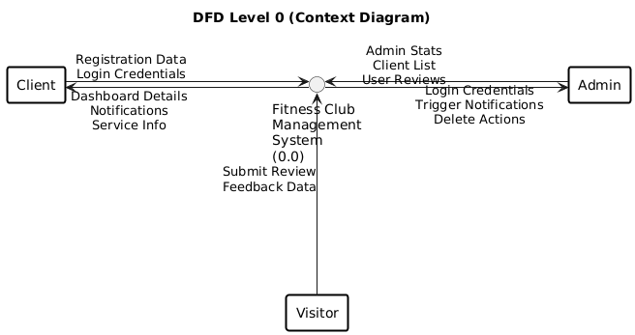

Level 1 (Detailed DFD): Breaks the system into key processes: User Authentication, Subscription Management, Dashboard Data Provisioning, and Review Management. Data stores include Users, Subscriptions, and Reviews tables.

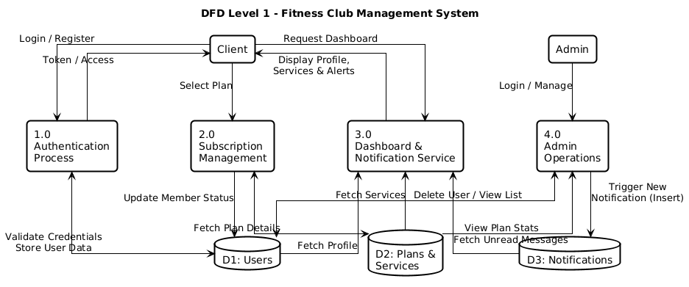

12. Web Design
Homepage: Includes a header with navigation, a "hero" section, a BMI calculator, a dynamic "Our Plans" section, a gallery, client reviews, and a contact form. An interactive goal-selector modal appears on first visit.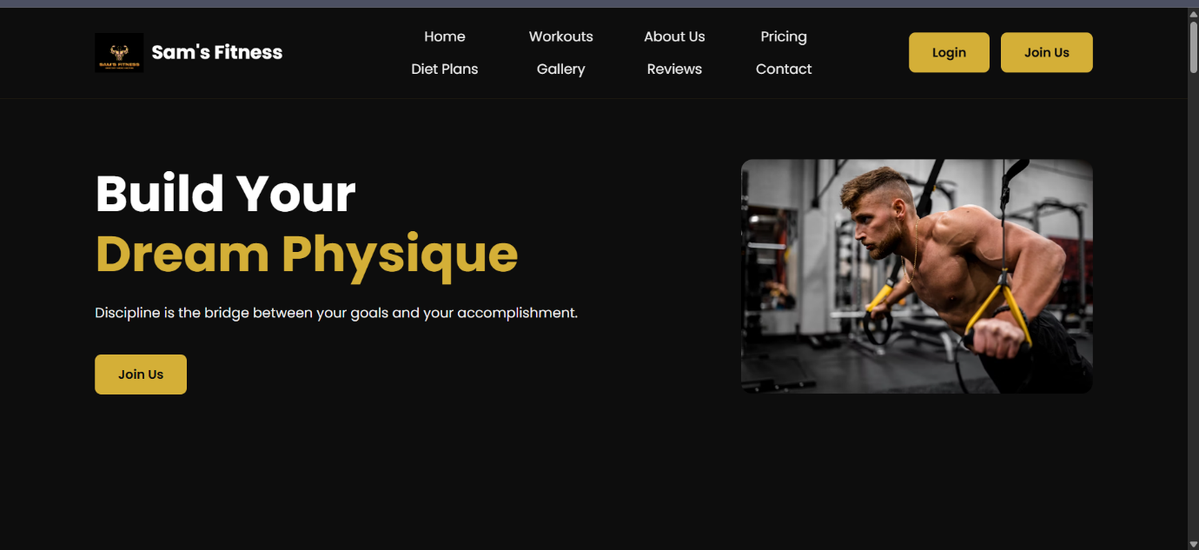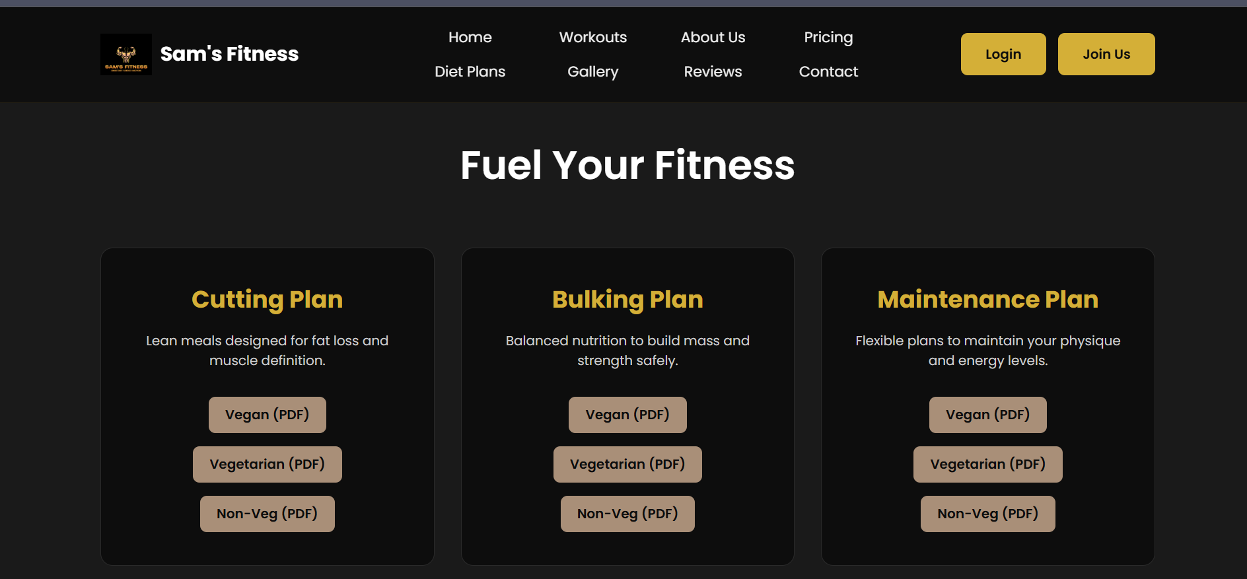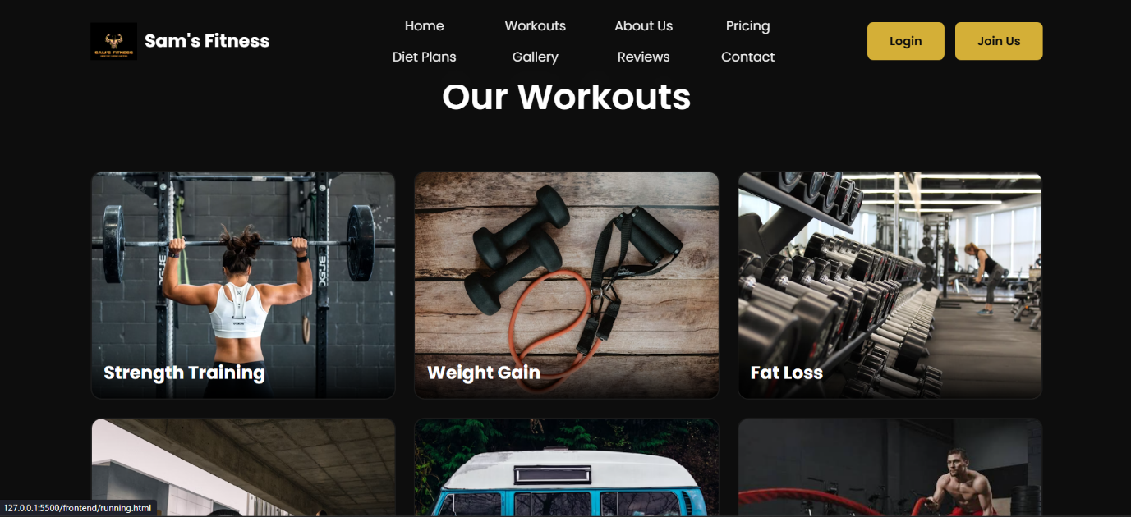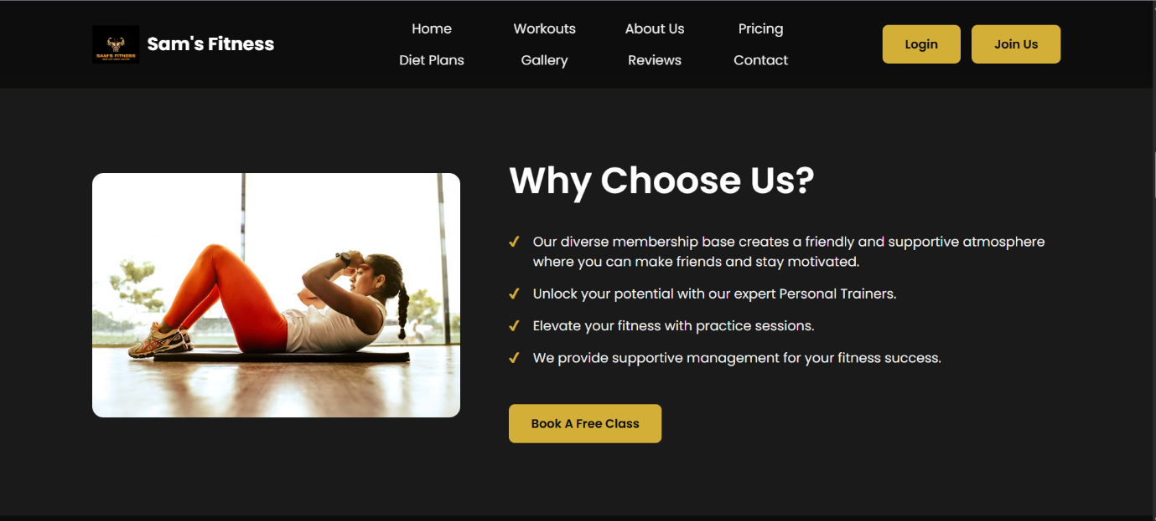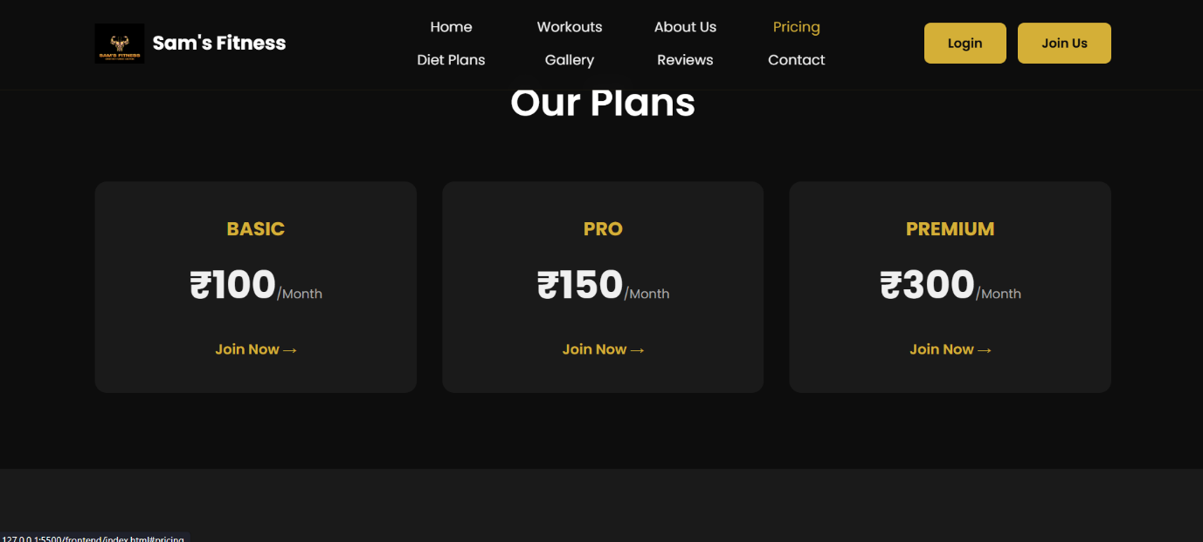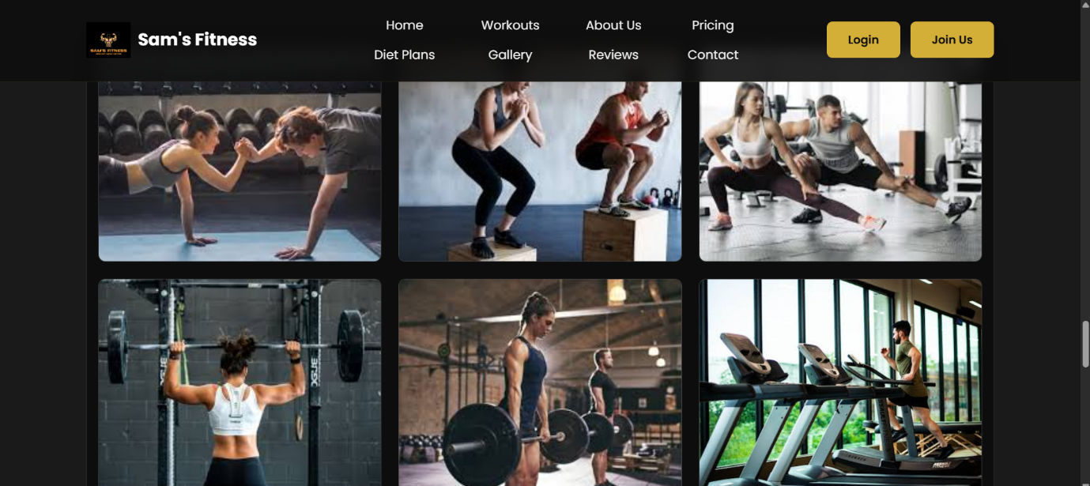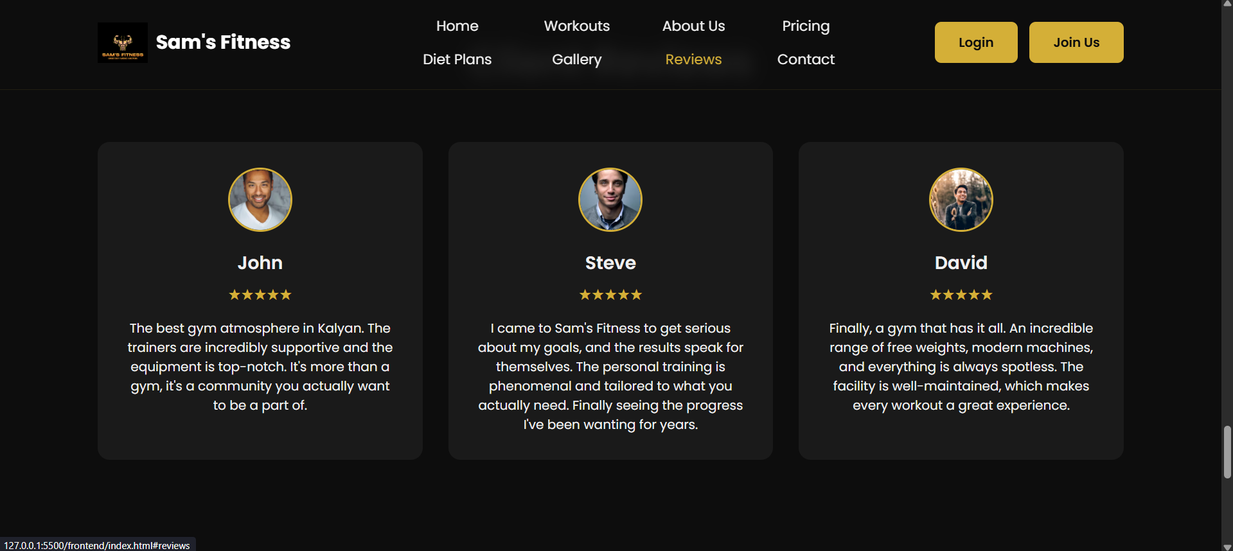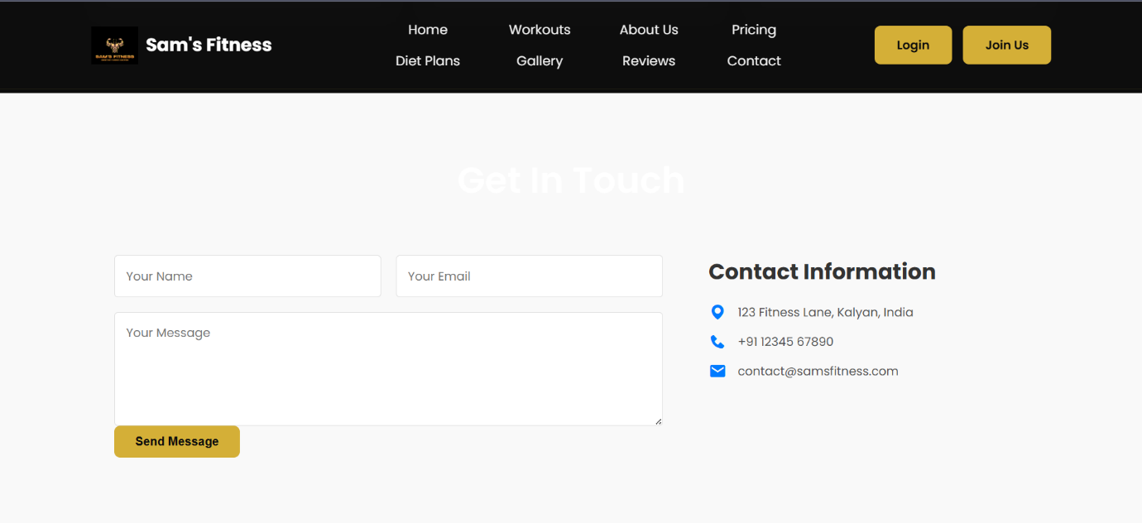

Admin Dashboard: A comprehensive dashboard featuring gold-colored analytic cards, a detailed client list with management actions (delete), and a table of user reviews.
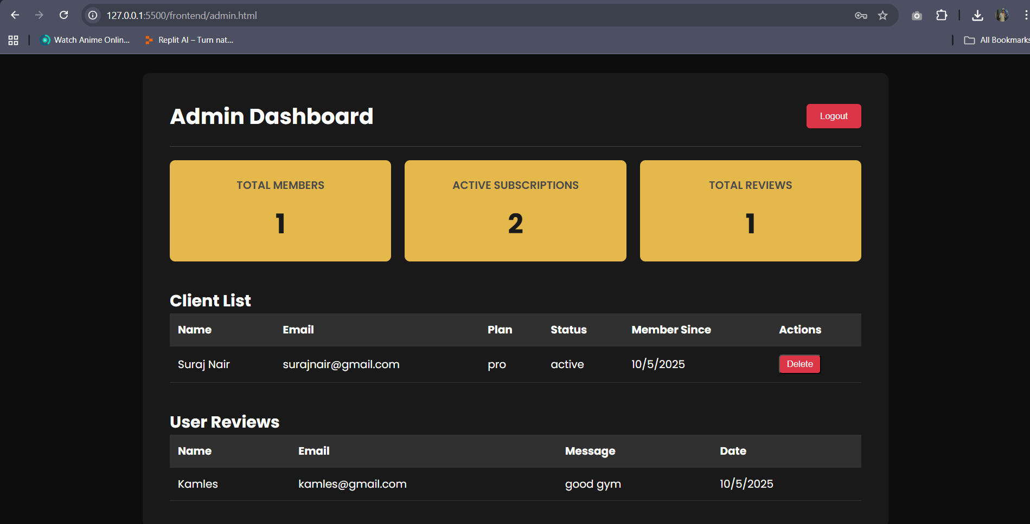

13. Methodology

An Iterative Development methodology was used, allowing for the progressive building and testing of features. The project architecture is based on the Model-View-Controller (MVC) pattern:

Model: The MySQL database schema and the backend logic that interacts with it.

View: The frontend HTML, CSS, and JavaScript files that render the user interface.

Controller: The Node.js/Express.js routes and controller functions that handle requests from the View and interact with the Model.

14. Development Environment

OS: Windows

Backend: Node.js, Express.js

Frontend: HTML, CSS, JavaScript

Database: MySQL (via XAMPP

IDE: Visual Studio Code

API Testing: Thunder Client

15. Hardware Requirements

Minimum:

Processor: Intel i3
RAM: 4GB
Storage: 250GB HDD

Recommended:

Processor: Intel i5 or higher
RAM: 8GB+
Storage: 500GB SSD

16. Tools and Technologies

Node.js v18+

Express.js

MySQL (managed by XAMPP)

HTML, CSS, JavaScript (ES6)

bcrypt.js (for password hashing)

jsonwebtoken (for JWT authentication)

GitHub for version control.

17. Database Design
The database is comprised of seven tables:

-- Users Table
CREATE TABLE Users (
user_id INT PRIMARY KEY AUTO_INCREMENT,
first_name VARCHAR(50) NOT NULL,
last_name VARCHAR(50) NOT NULL,
email VARCHAR(100) NOT NULL UNIQUE,
password VARCHAR(255) NOT NULL,
phone_number VARCHAR(20),
join_date TIMESTAMP DEFAULT CURRENT_TIMESTAMP,
role ENUM('client', 'admin') NOT NULL DEFAULT 'client'
);

-- Plans Table
CREATE TABLE Plans (
plan_id INT PRIMARY KEY AUTO_INCREMENT,
plan_name VARCHAR(100) NOT NULL,
price DECIMAL(10, 2) NOT NULL,
duration_days INT NOT NULL
);

-- Services Table
CREATE TABLE Services (
service_id INT PRIMARY KEY AUTO_INCREMENT,
service_name VARCHAR(100) NOT NULL UNIQUE
);

-- Plan_Services Linking Table
CREATE TABLE Plan_Services (
plan_service_id INT PRIMARY KEY AUTO_INCREMENT,
plan_id INT,
service_id INT,
FOREIGN KEY (plan_id) REFERENCES Plans(plan_id),
FOREIGN KEY (service_id) REFERENCES Services(service_id)
);

-- Subscriptions Table
CREATE TABLE Subscriptions (
subscription_id INT PRIMARY KEY AUTO_INCREMENT,
user_id INT,
plan_id INT,
start_date DATE NOT NULL,
end_date DATE NOT NULL,
status ENUM('active', 'expired', 'cancelled') NOT NULL DEFAULT 'active',
FOREIGN KEY (user_id) REFERENCES Users(user_id) ON DELETE CASCADE,
FOREIGN KEY (plan_id) REFERENCES Plans(plan_id)
);

-- Reviews Table
CREATE TABLE Reviews (
review_id INT PRIMARY KEY AUTO_INCREMENT,
name VARCHAR(100) NOT NULL,
email VARCHAR(100) NOT NULL,
message TEXT NOT NULL,
created_at TIMESTAMP DEFAULT CURRENT_TIMESTAMP
);
-- Notifications Table
CREATE TABLE Notifications (
notification_id INT PRIMARY KEY AUTO_INCREMENT,
user_id INT NOT NULL,
title VARCHAR(100),
message TEXT,
is_read TINYINT(1) DEFAULT 0, -- 0 = Unread, 1 = Read
created_at TIMESTAMP DEFAULT CURRENT_TIMESTAMP,
FOREIGN KEY (user_id) REFERENCES Users(user_id) ON DELETE CASCADE
);

18. System Requirements

Software: A modern web browser, Node.js, and a MySQL server (XAMPP).

Hardware: Minimum 4GB RAM, 250GB HDD.

Network: Internet access for the frontend to communicate with the backend API.

19. Validations

Frontend:
required attribute on form inputs to prevent empty submissions.

Backend:
Unique Email: Prevents multiple users from registering with the same email.
Password Hashing: bcrypt.js is used to securely hash and compare passwords.
JWT Authentication: authMiddleware protects routes by validating tokens.
Role-Based Authorization: isAdmin middleware restricts access to admin-only endpoints.

Plan Validation: Checks if a plan selected during registration exists in the database.

20. System Code

The full source code is located in the frontend and backend directories of the project. A key code snippet is the admin authorization middleware, which is fundamental to the system's security.

backend/middleware/authMiddleware.js:

const jwt = require('jsonwebtoken');

// Middleware to check for a valid JWT
exports.authMiddleware = (req, res, next) => {
const token = req.header('x-auth-token');
if (!token) {
return res.status(401).json({ message: 'No token, authorization denied.' });
}
try {
const decoded = jwt.verify(token, 'your_super_secret_key_that_is_long_and_random');
req.user = decoded.user;
next();
} catch (err) {
res.status(401).json({ message: 'Token is not valid.' });
}
};

// Middleware to check if the user has an 'admin' role
exports.isAdmin = (req, res, next) => {
if (req.user.role !== 'admin') {
return res.status(403).json({ message: 'Access denied. Requires admin role.' });
}
next();
};

Index.html –
<!DOCTYPE html>
<html lang="en">
<head>
<meta charset="UTF-8">
<meta name="viewport" content="width=device-width, initial-scale=1.0">
<title>Sam's Fitness </title>

<link rel="stylesheet" href="style.css">

<link rel="preconnect" href="https://fonts.googleapis.com">
<link rel="preconnect" href="https://fonts.gstatic.com" crossorigin>
<link href="https://fonts.googleapis.com/css2?family=Poppins:wght@300;400;600;700&display=swap" rel="stylesheet">

<link href='https://unpkg.com/boxicons@2.1.4/css/boxicons.min.css' rel='stylesheet'>

<script src="script.js" defer></script>
</head>

<body>

<header class="header">
<a href="index.html" class="logo">
<img src="images/your-logo.png" alt="Sam's Fitness Logo">
<span>Sam's Fitness</span> </a>

<nav class="navbar">
<a href="#home">Home</a>
<a href="#workouts">Workouts</a>
<a href="#about">About Us</a>
<a href="#pricing">Pricing</a>
<a href="#diet-plans">Diet Plans</a>
<a href="#gallery">Gallery</a>
<a href="#reviews">Reviews</a>
<a href="#contact">Contact</a>
</nav>

<div class="header-buttons">
<a href="login.html" class="btn">Login</a>
<a href="register.html" class="btn">Join Us</a>
</div>
</header>

<main>
<section class="home" id="home">
<div class="home-content">
<h1>Build Your <span class="typewriter">Dream Physique</span></h1>
<p>Discipline is the bridge between your goals and your accomplishment. </p>
<a href="#pricing" class="btn">Join Us</a>
</div>
<div class="home-image">
<img src="https://images.unsplash.com/photo-1581009137042-c552e485697a?auto=format&fit=crop&w=800" alt="Man with a fit physique">
</div>
</section>

<section class="services section-hidden" id="workouts">
<h2 class="section-title">Our Workouts</h2>
<div class="services-container">
<a href="strength-training.html" class="service-link">
<div class="service-card">
<img src="https://images.unsplash.com/photo-1541534741688-6078c6bfb5c5?auto=format&fit=crop&w=800" alt="Strength Training">
<h3>Strength Training</h3>
</div>
</a>
<a href="weight-gain.html" class="service-link">
<div class="service-card">
<img src="https://images.unsplash.com/photo-1584735935682-2f2b69dff9d2?auto=format&fit=crop&w=800" alt="Weight Gain">
<h3>Weight Gain</h3>
</div>
</a>
<a href="fat-loss.html" class="service-link">
<div class="service-card">
<img src="https://images.unsplash.com/photo-1534438327276-14e5300c3a48?auto=format&fit=crop&w=800" alt="Fat Lose">
<h3>Fat Loss</h3>
</div>
</a>
<a href="weightlifting.html" class="service-link">
<div class="service-card">
<img src="https://images.unsplash.com/photo-1599058917212-d750089bc07e?auto=format&fit=crop&w=800" alt="Weightlifting">
<h3>Weightlifting</h3>
</div>
</a>
<a href="running.html" class="service-link">
<div class="service-card">
<img src="https://images.unsplash.com/photo-1423439793616-f2aa4356b37e?auto=format&fit=crop&w=800" alt="Running">
<h3>Running</h3>
</div>
</a>
<a href="crossfit.html" class="service-link">
<div class="service-card">
<img src="images/your-crossfit-card-image.jpg" alt="CrossFit">
<h3>CrossFit</h3>
</div>
</a>
<a href="yoga.html" class="service-link">
<div class="service-card">
<img src="https://images.unsplash.com/photo-1544367567-0f2fcb009e0b?auto=format&fit=crop&w=800" alt="Yoga">
<h3>Yoga</h3>
</div>
</a>
<a href="steam-sauna.html" class="service-link">
<div class="service-card">
<img src="images/your-sauna-card-image.jpg" alt="Sauna/Steam">
<h3>Sauna/Steam</h3>
</div>
</a>
<div class="service-card">
<img src="https://images.unsplash.com/photo-1571902943202-507ec2618e8f?auto=format&fit=crop&w=800" alt="Physical Fitness">
<h3>Physical Fitness</h3>
</div>
</div>
</section>

<section class="about section-hidden" id="about">
<div class="about-image">
<img src="https://images.unsplash.com/photo-1571019613454-1cb2f99b2d8b?auto=format&fit=crop&w=800" alt="Man on treadmill">
</div>
<div class="about-content">
<h2 class="section-title">Why Choose Us?</h2>
<ul>
<li>Our diverse membership base creates a friendly and supportive atmosphere where you can make friends and stay motivated.</li>
<li>Unlock your potential with our expert Personal Trainers.</li>
<li>Elevate your fitness with practice sessions.</li>
<li>We provide supportive management for your fitness success.</li>
</ul>
<a href="register.html?plan=trial" class="btn">Book A Free Class</a>
</div>
</section>

<section class="pricing section-hidden" id="pricing">
<h2 class="section-title">Our Plans</h2>
<!-- REPLACE the existing pricing-container div with this one -->
<div class="pricing-container">
<div class="plan-card">
<h3>BASIC</h3>
<p class="price">₹100<span>/Month</span></p>
<ul id="plan-basic-services">
<!-- Services will be loaded here by JavaScript -->
</ul>
<a href="register.html?plan=basic">Join Now &rarr;</a>
</div>
<div class="plan-card">
<h3>PRO</h3>
<p class="price">₹150<span>/Month</span></p>
<ul id="plan-pro-services">
<!-- Services will be loaded here by JavaScript -->
</ul>
<a href="register.html?plan=pro">Join Now &rarr;</a>
</div>
<div class="plan-card">
<h3>PREMIUM</h3>
<p class="price">₹300<span>/Month</span></p>
<ul id="plan-premium-services">
<!-- Services will be loaded here by JavaScript -->
</ul>
<a href="register.html?plan=premium">Join Now &rarr;</a>
</div>
</div>
</section>

<section class="diet-plans section-hidden" id="diet-plans">
<h2 class="section-title">Fuel Your Fitness</h2>
<div class="diet-card-container">
<div class="diet-card">
<h3>Cutting Plan</h3>
<p>Lean meals designed for fat loss and muscle definition.</p>
<div class="diet-buttons">
<a href="diet-plans/cutting_vegan.pdf" download class="btn-diet">Vegan (PDF)</a>
<a href="diet-plans/cutting_vegetarian.pdf" download class="btn-diet">Vegetarian (PDF)</a>
<a href="diet-plans/cutting_nonveg.pdf" download class="btn-diet">Non-Veg (PDF)</a>
</div>
</div>
<div class="diet-card">
<h3>Bulking Plan</h3>
<p>Balanced nutrition to build mass and strength safely.</p>
<div class="diet-buttons">
<a href="diet-plans/bulking_vegan.pdf" download class="btn-diet">Vegan (PDF)</a>
<a href="diet-plans/bulking_vegetarian.pdf" download class="btn-diet">Vegetarian (PDF)</a>
<a href="diet-plans/bulking_nonveg.pdf" download class="btn-diet">Non-Veg (PDF)</a>
</div>
</div>
<div class="diet-card">
<h3>Maintenance Plan</h3>
<p>Flexible plans to maintain your physique and energy levels.</p>
<div class="diet-buttons">
<a href="diet-plans/maintenance_vegan.pdf" download class="btn-diet">Vegan (PDF)</a>
<a href="diet-plans/maintenance_vegetarian.pdf" download class="btn-diet">Vegetarian (PDF)</a>
<a href="diet-plans/maintenance_nonveg.pdf" download class="btn-diet">Non-Veg (PDF)</a>
</div>
</div>
</div>
</section>
<!-- =============== BMI CALCULATOR SECTION =============== -->
<section class="bmi-calculator section-hidden" id="bmi">
<h2 class="section-title">Calculate Your BMI</h2>
<div class="bmi-container">
<div class="bmi-inputs">
<div class="input-group-bmi">
<label for="height">Height (cm)</label>
<input type="number" id="height" placeholder="e.g., 175">
</div>
<div class="input-group-bmi">
<label for="weight">Weight (kg)</label>
<input type="number" id="weight" placeholder="e.g., 70">
</div>
</div>
<button id="calculate-bmi" class="btn">Calculate</button>
<div id="bmi-result" class="bmi-result-display">
<!-- Result will be shown here -->
</div>
</div>
</section>
<section class="gallery section-hidden" id="gallery">
<h2 class="section-title">Our Gallery</h2>
<div class="gallery-grid">
<div class="gallery-item">
<img src="images/gallery1.jpg" alt="Gym image 1">
</div>
<div class="gallery-item">
<img src="images/gallery2.jpg" alt="Gym image 2">
</div>
<div class="gallery-item">
<img src="images/gallery3.jpg" alt="Gym image 3">
</div>
<div class="gallery-item">
<img src="images/gallery4.jpg" alt="Gym image 4">
</div>
<div class="gallery-item">
<img src="images/gallery5.jpg" alt="Gym image 5">
</div>
<div class="gallery-item">
<img src="images/gallery6.jpg" alt="Gym image 6">
</div>
</div>
</section>
<section class="reviews section-hidden" id="reviews">
<h2 class="section-title">Client Reviews</h2>
<div class="reviews-container">
<div class="review-card">
<img src="https://images.unsplash.com/photo-1507003211169-0a1dd7228f2d?auto=format&fit=crop&w=200&h=200" alt="John">
<h4>John</h4>
<div class="stars">★★★★★</div>
<p>The best gym atmosphere in Kalyan. The trainers are incredibly supportive and the equipment is top-notch. It's more than a gym, it's a community you actually want to be a part of.</p>
</div>
<div class="review-card">
<img src="https://images.unsplash.com/photo-1500648767791-00dcc994a43e?auto=format&fit=crop&w=200&h=200" alt="Steve">
<h4>Steve</h4>
<div class="stars">★★★★★</div>
<p>I came to Sam's Fitness to get serious about my goals, and the results speak for themselves. The personal training is phenomenal and tailored to what you actually need. Finally seeing the progress I've been wanting for years.</p>
</div>
<div class="review-card">
<img src="https://images.unsplash.com/photo-1492562080023-ab3db95bfbce?auto=format&fit=crop&w=200&h=200" alt="David">
<h4>David</h4>
<div class="stars">★★★★★</div>
<p>Finally, a gym that has it all. An incredible range of free weights, modern machines, and everything is always spotless. The facility is well-maintained, which makes every workout a great experience.</p>
</div>
</div>
</section>
<section class="contact section-hidden" id="contact">
<h2 class="section-title">Get In Touch</h2>
<div class="contact-container">
<form id="contact-form" class="contact-form">
<div class="input-group">
<input type="text" id="contact-name" placeholder="Your Name" required>
<input type="email" id="contact-email" placeholder="Your Email" required>
</div>
<textarea id="contact-message" placeholder="Your Message" rows="5" required></textarea>
<button type="submit" class="btn">Send Message</button>
<div id="contact-response" style="text-align:center; margin-top:15px; color:#28a745;"></div>
</form>
<div class="contact-info">
<h3>Contact Information</h3>
<p><i class='bx bxs-map'></i> 123 Fitness Lane, Kalyan, India</p>
<p><i class='bx bxs-phone'></i> +91 12345 67890</p>
<p><i class='bx bxs-envelope'></i> contact@samsfitness.com</p>
</div>
</div>
</section>
<!-- =============== GOAL SELECTION MODAL =============== -->
<div id="goal-modal-overlay" class="modal-overlay hidden">
<div class="modal-content">
<button id="close-modal-btn" class="close-btn">&times;</button>

<!-- Step 1: Goal Selection View -->
<div id="goal-selection-view">
<h2 class="modal-title">What's Your Primary Goal?</h2>
<p class="modal-subtitle">Select a goal to get a personalized plan recommendation.</p>
<div class="goal-grid">
<button class="goal-btn" data-goal="basic">Get Fit & Healthy</button>
<button class="goal-btn" data-goal="basic">Start My Fitness Journey</button>
<button class="goal-btn" data-goal="pro">Build Muscle & Strength</button>
<button class="goal-btn" data-goal="pro">Lose Weight & Tone Up</button>
<button class="goal-btn" data-goal="premium">Total Body Transformation</button>
<button class="goal-btn" data-goal="premium">Enhance Athletic Performance</button>
</div>
</div>

<!-- Step 2: Plan Suggestion View (Initially Hidden) -->
<div id="plan-suggestion-view" class="hidden">
<h2 class="modal-title">Our Recommendation For You!</h2>
<div id="suggested-plan-card" class="plan-card" style="margin-top: 20px;">
<h3 id="suggested-plan-name">PLAN NAME</h3>
<p id="suggested-plan-price" class="price">₹150<span>/Month</span></p>
<ul id="suggested-plan-services">
<!-- Services will be loaded here -->
</ul>
<a id="suggested-plan-link" href="#" class="btn">Join Now &rarr;</a>
</div>
<button id="back-to-goals-btn" class="back-btn">Choose a Different Goal</button>
</div>
</div>
</div>
</main>

<footer class="footer section-hidden">
<div class="social-links">
<a href="#"><i class='bx bxl-instagram-alt'></i></a>
<a href="#"><i class='bx bxl-twitter'></i></a>
<a href="#"><i class='bx bxl-linkedin-square'></i></a>
</div>
<p>&copy; Sam's Fitness 2025 - All Rights Reserved</p>
</footer>

</body>
</html>

Admin.html—
<!DOCTYPE html>
<html lang="en">
<head>
<meta charset="UTF-8">
<meta name="viewport" content="width=device-width, initial-scale=1.0">
<title>Admin Dashboard - Sam's Fitness</title>

<link rel="stylesheet" href="style.css">

<link rel="preconnect" href="https://fonts.googleapis.com">
<link rel="preconnect" href="https://fonts.gstatic.com" crossorigin>
<link href="https://fonts.googleapis.com/css2?family=Poppins:wght@300;400;600;700&display=swap" rel="stylesheet">

<style>
body { background: #0d0d0d; color: #fff; }
.dashboard-container { max-width: 1100px; margin: 50px auto; padding: 40px; background: rgba(255, 255, 255, 0.05); border-radius: 10px; }
.dashboard-header { display: flex; justify-content: space-between; align-items: center; border-bottom: 1px solid #444; padding-bottom: 20px; margin-bottom: 20px; }
#logout-button { background: #dc3545; padding: 10px 20px; border-radius: 5px; text-decoration: none; color: #fff; cursor: pointer; border: none; }

.stats-grid { display: grid; grid-template-columns: repeat(auto-fit, minmax(250px, 1fr)); gap: 20px; margin-bottom: 40px; }
.stat-card { background-color: #E5B84B; padding: 25px; border-radius: 8px; text-align: center; }
.stat-card h3 { font-size: 1rem; font-weight: 600; color: #4a4a4a; margin-bottom: 15px; text-transform: uppercase; }
.stat-card p { font-size: 2.5rem; font-weight: 700; color: #1a1a1a; }

.client-table { width: 100%; border-collapse: collapse; }
.client-table th, .client-table td { padding: 12px; border-bottom: 1px solid #333; text-align: left; }
.client-table th { background-color: rgba(255, 255, 255, 0.1); }
.tooltip-container { position: relative; cursor: help; }
.tooltip-text { visibility: hidden; width: 280px; background-color: #2a2a2a; color: #fff; text-align: left; border-radius: 6px; padding: 10px; position: absolute; z-index: 1; bottom: 125%; left: 50%; margin-left: -140px; opacity: 0; transition: opacity 0.3s; white-space: pre-line; box-shadow: 0 4px 8px rgba(0, 0, 0, 0.3); border: 1px solid #444; }
.tooltip-text::after { content: ""; position: absolute; top: 100%; left: 50%; margin-left: -5px; border-width: 5px; border-style: solid; border-color: #2a2a2a transparent transparent transparent; }
.tooltip-container:hover .tooltip-text { visibility: visible; opacity: 1; }
</style>
</head>
<body>
<div class="dashboard-container">
<div class="dashboard-header">
<h1>Admin Dashboard</h1>
<button id="logout-button">Logout</button>
</div>

<div class="stats-grid">
<div class="stat-card">
<h3>Total Members</h3>
<p id="total-members-stat">--</p>
</div>
<div class="stat-card">
<h3>Active Subscriptions</h3>
<p id="active-subs-stat">--</p>
</div>
<div class="stat-card">
<h3>Total Reviews</h3>
<p id="total-reviews-stat">--</p>
</div>
</div>

<h2>Client List</h2>
<table class="client-table">
<thead>
<tr>
<th>Name</th>
<th>Email</th>
<th>Plan</th>
<th>Status</th>
<th>Member Since</th>
<th>Actions</th>
</tr>
</thead>
<tbody id="client-list-body"></tbody>
</table>

<h2 style="margin-top: 40px;">User Reviews</h2>
<table class="client-table">
<thead>
<tr>
<th>Name</th>
<th>Email</th>
<th>Message</th>
<th>Date</th>
</tr>
</thead>
<tbody id="review-list-body"></tbody>
</table>
</div>

<script src="script.js"></script>
</body>
</html>

21. System Screenshots
Figure 1: Admin Dashboard


Figure 2: Client Dashboard
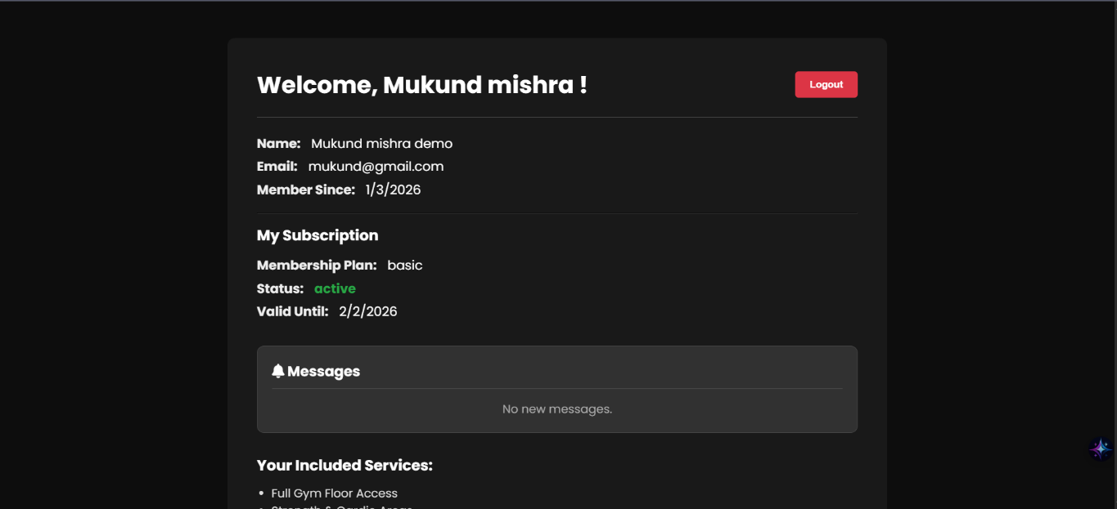

Figure 3: Homepage with Goal Selector Pop-up
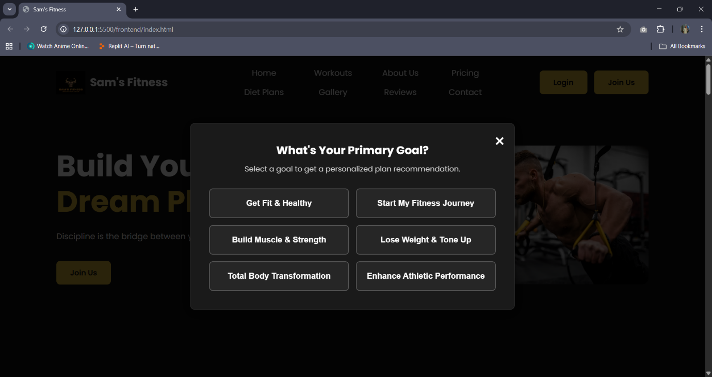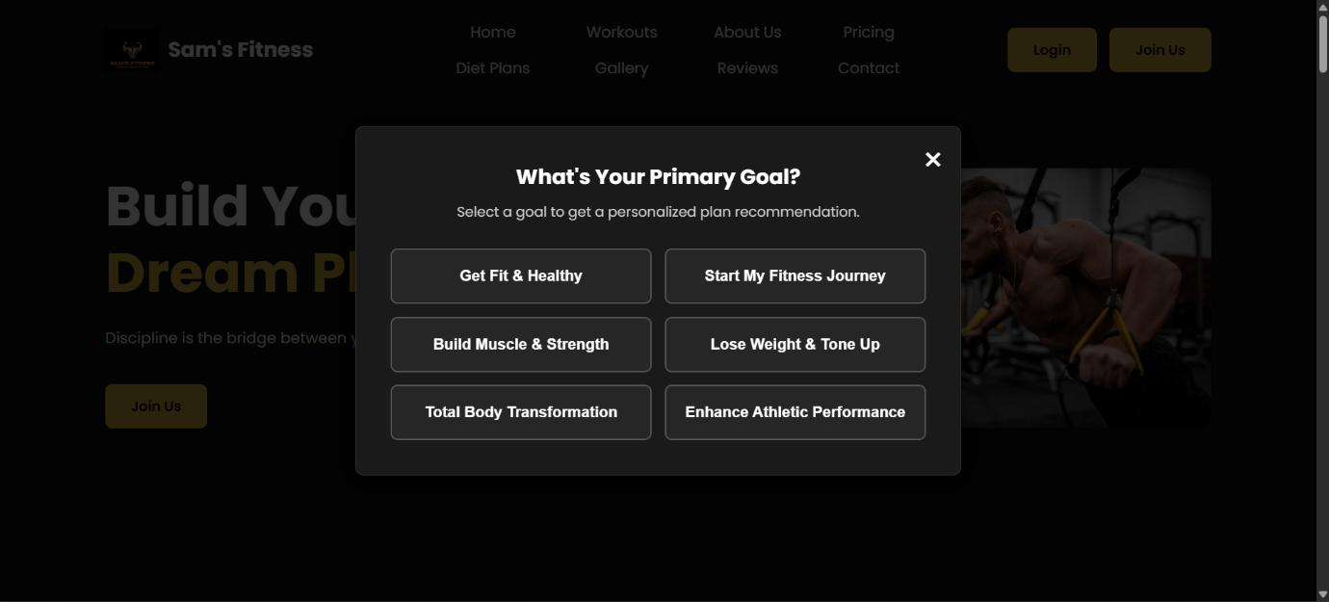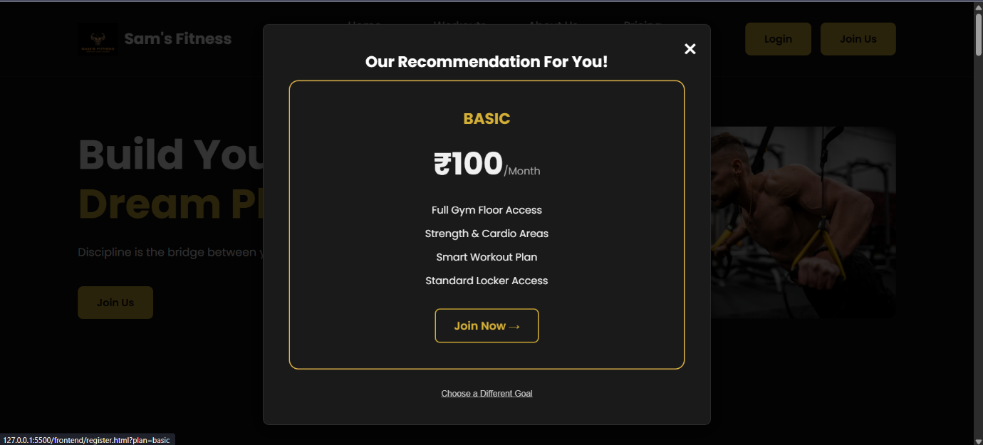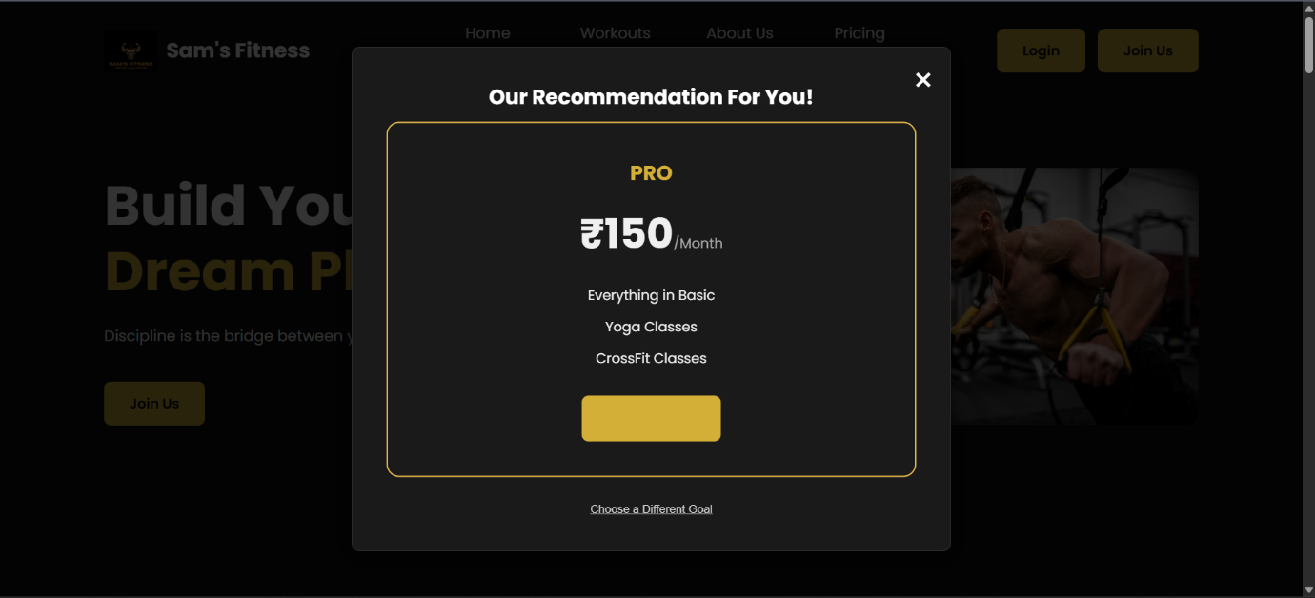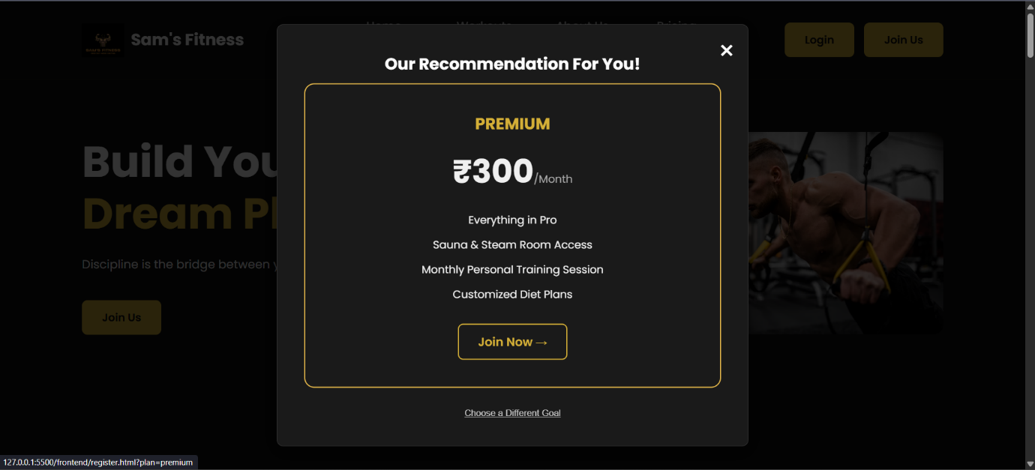

22. White Box and Black Box Testing

White Box: Unit testing was conceptually applied. For instance, testing the getDashboardStats controller to ensure it returns the correct counts from the database, and testing the authMiddleware to ensure it correctly validates and rejects tokens.

Black Box: Functional testing was performed extensively using the browser and Thunder Client. Test cases included successful user registration, handling of duplicate emails, admin login and redirection, client login and redirection, and verifying that the delete functionality works as expected.

23. Future Enhancements
Payment Gateway Integration to allow online payments for subscriptions.

Advanced Admin Controls such as editing a client's details or manually updating their subscription plan.

Cloud-based deployment on a platform like Heroku or AWS to make the application publicly accessible.

Password Reset functionality for users who forget their password.

24. Bibliography

Node.js Official Documentation – https://nodejs.org/

Express.js Official Documentation – https://expressjs.com/

MySQL Official Documentation – https://dev.mysql.com/doc/

MDN Web Docs (for HTML, CSS, JavaScript) – https://developer.mozilla.org/

JWT.io (JSON Web Tokens) –
https://jwt.io/

